**AGE FOR 5 PERSONS WITHOUT LOOP**

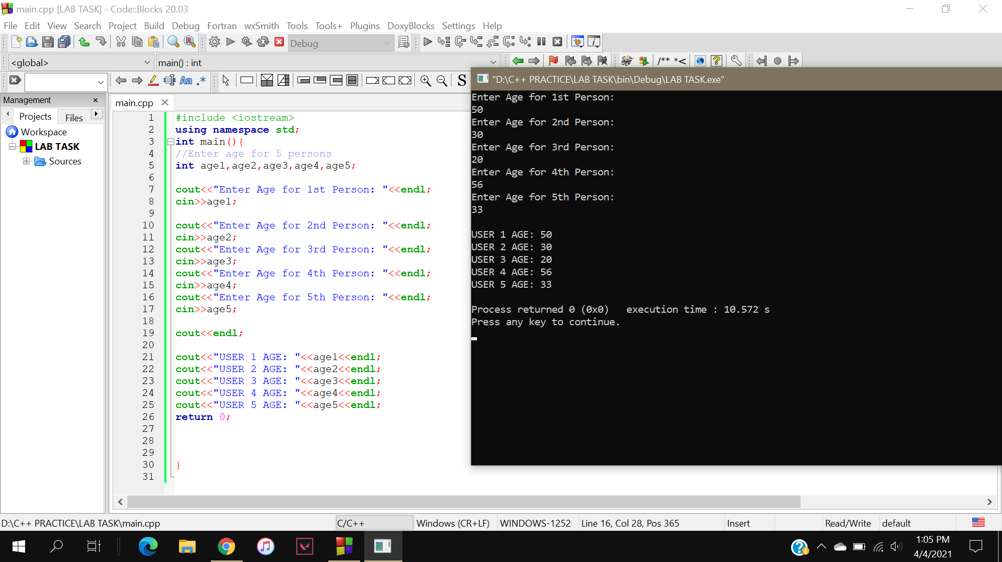

AGE OF 5 PERSONS WITH LOOP AND ARRAY

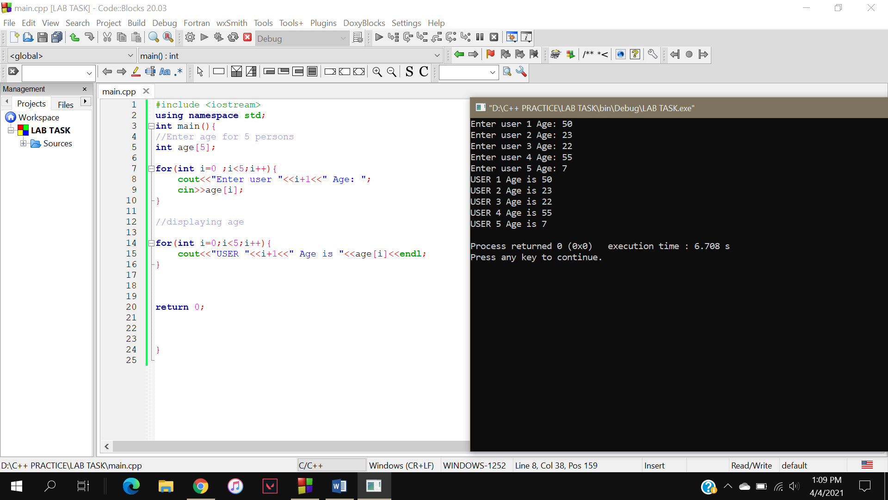

Basic syntax of Structure

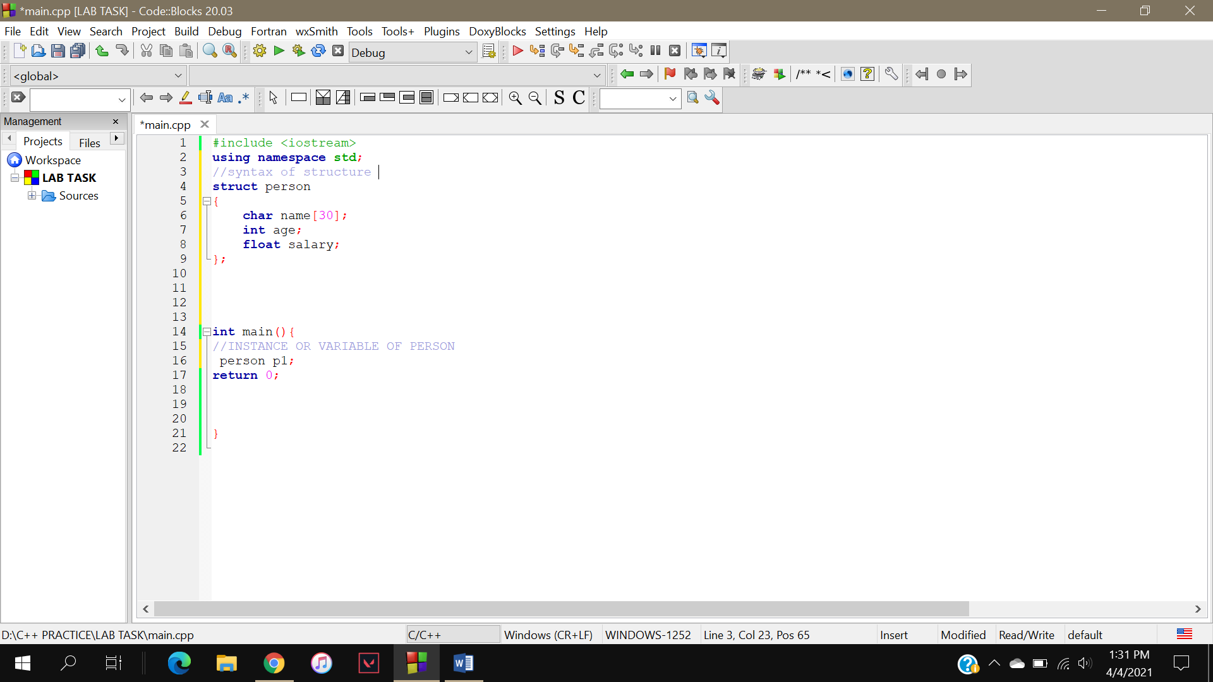

STUDENT NAME ROLL AGE USING STRUCTURE

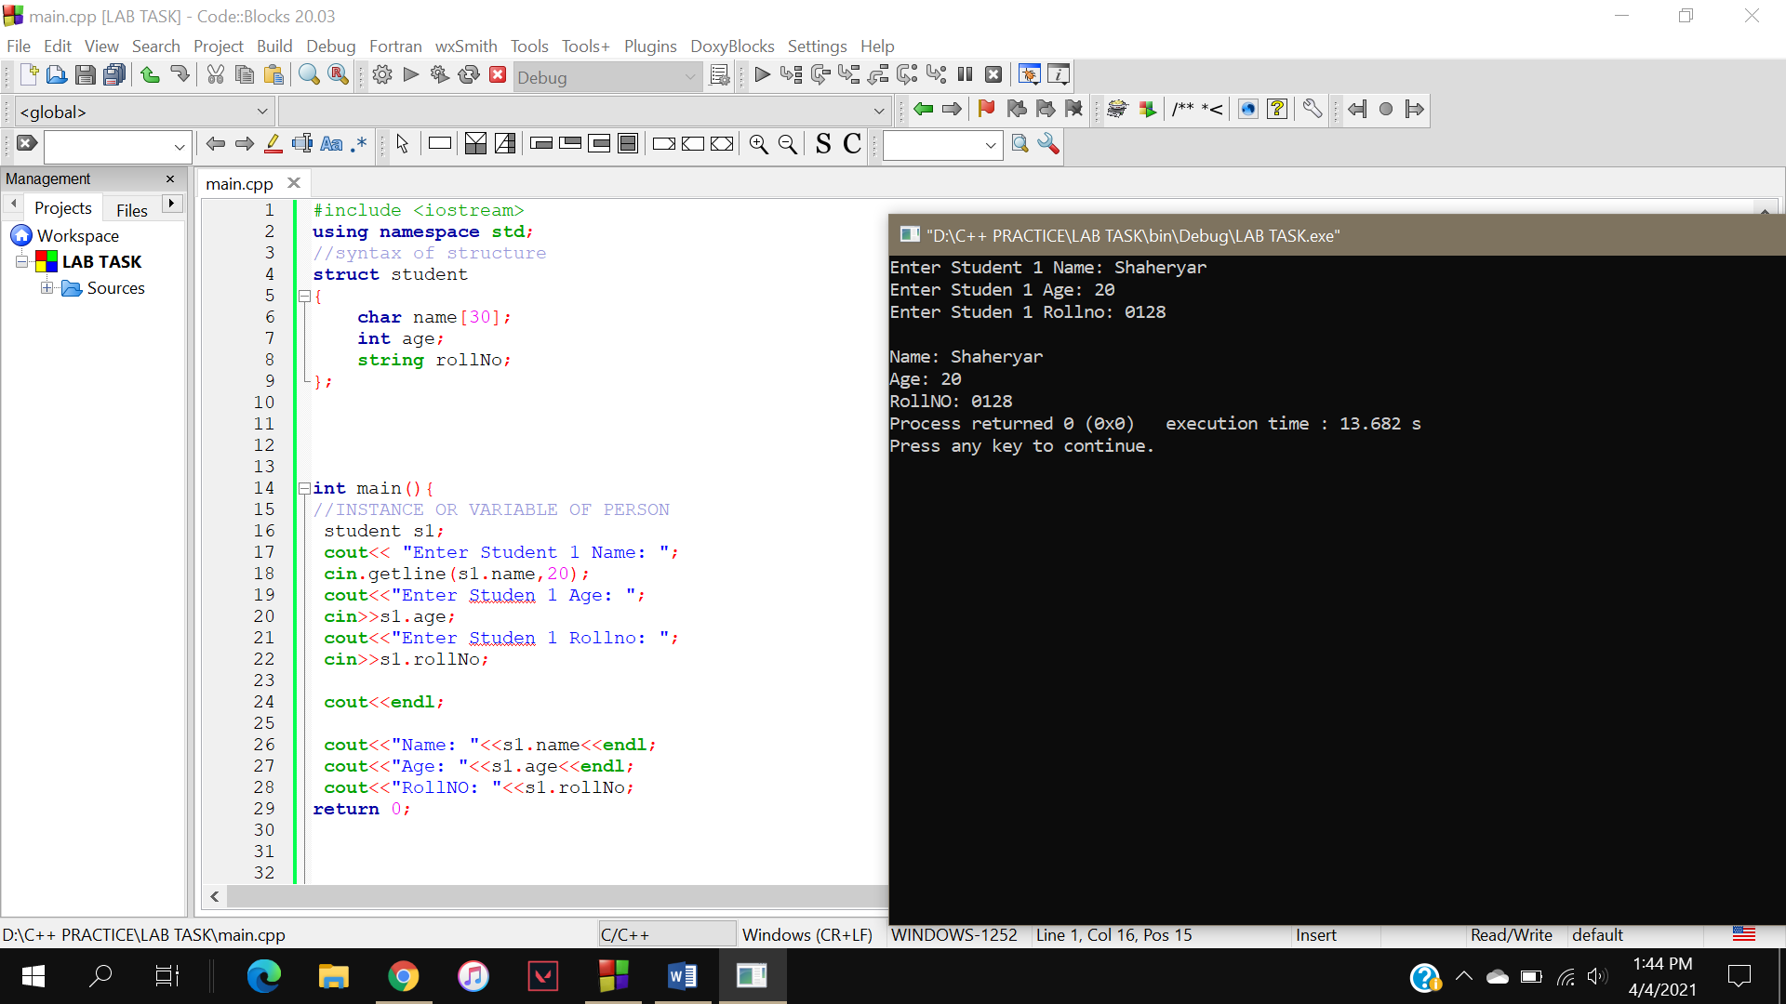

For more then 1 Student

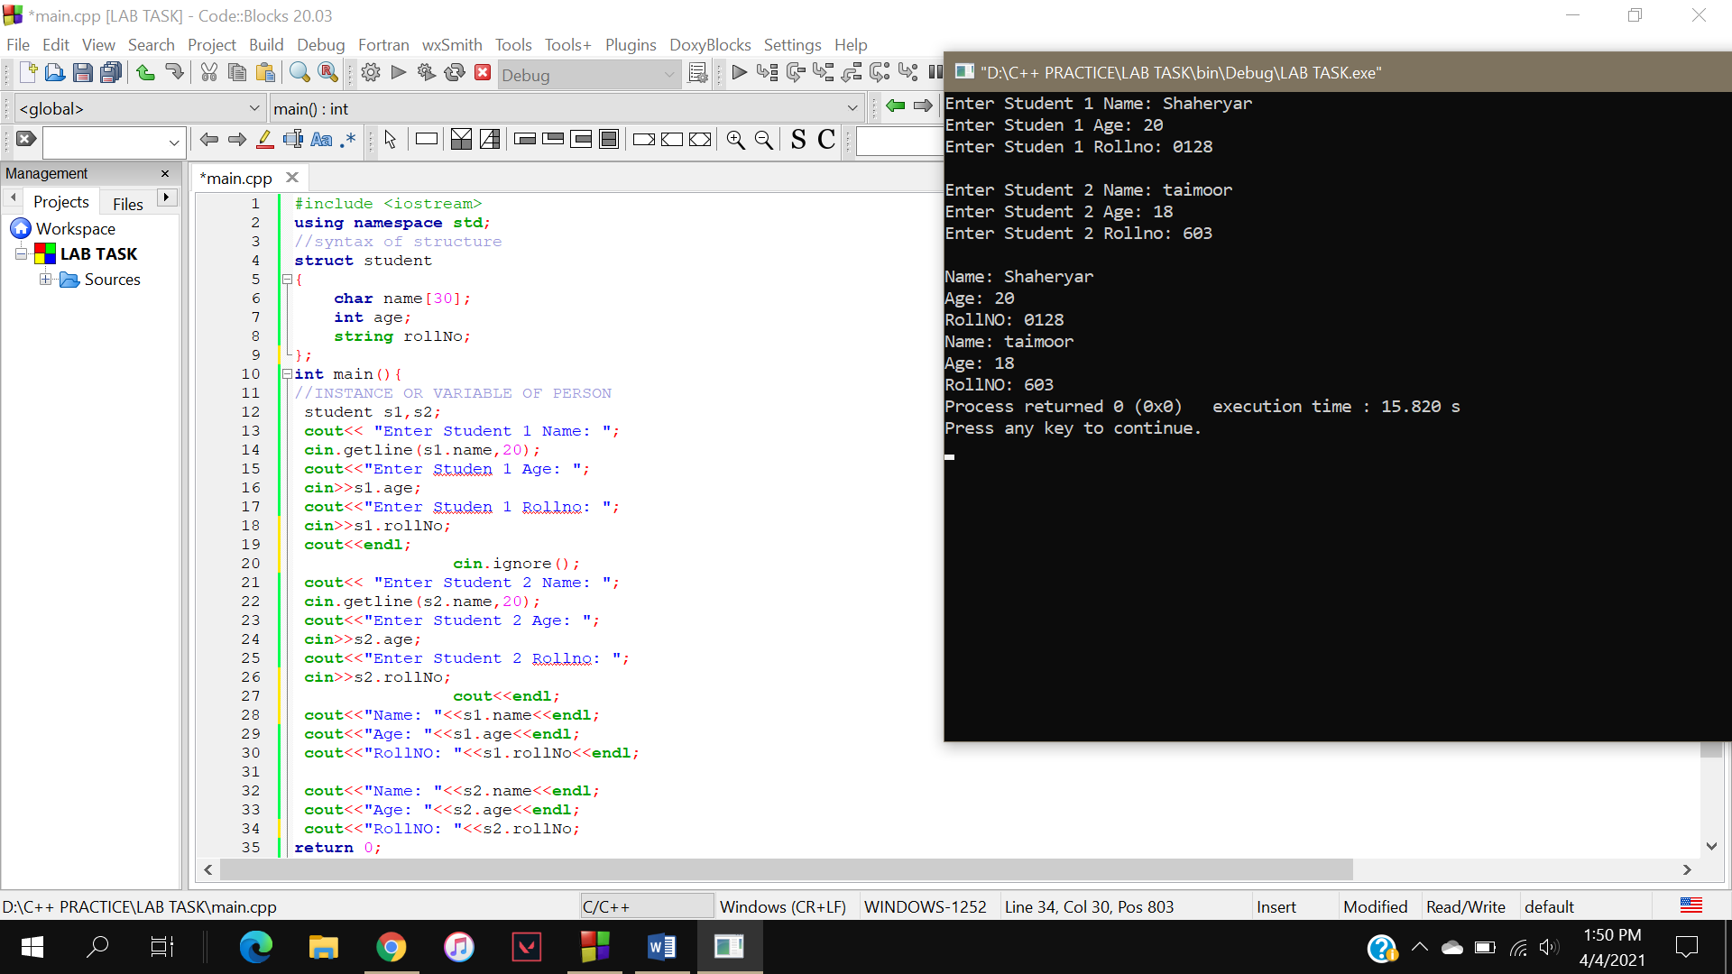

STRUCTURE WITH LOOPS AND ARRAYS

